V.S AGRICULTURE SENIOR SECONDARY SCHOOL ,KHERA KALAN



ACADEMIC YEAR : 2024 – 25 PROJECT REPORT ON CRICKET GAME PROJECT

NAME : SONU KUMAR
ROLL NO. : 14 STUDENT ID : 2020009401

SUBJECT : COMPUTER SCIENCE SUB CODE : 083

CLASS

: 12th‘ A

PROJECT GUIDE : MANJU DHANKAR

CERTIFICATE

This is to certify that SONU KUMAR Roll No : _14 has successfully
Completed the work entitled “ Cricket Game Project “ in the subject computer science (083) laid down in the regulations of CBSE for the purpose of practical examination in class 12th to be held in V.S AGRICULTURE SENIOR SECONDARY SCHOOL .(KHERA KALAN )

MANJU DHANKAR
PGT Comp. sci.

Table of Contents [ T O C ]
SER. NO. | Description | Page NO.
01 | ACKNOWLEDGEMENT | 1
02 | INTRODUCTION | 2
03 | OBJECTIVES OF THE PROJECT | 2
04 | CODE | 3
05 | OUTPUT | 12
06 | BIBLIOGRAPHY | 17

ACKNOWLEDGEMENT
Apart from the efforts of me , the success of any project depends
largely on the encouragement and guidelines of many others . I take
this opportunity to express my gratitude to the people who have been instrumental in the successful completion of this project .
I expresss deep sense of gratitude to almighty God for giving me strength for the successful completion of the project .
I express my heartfelt gratitude to my parents for constant encouragement while carry out this project .
I express acknowledge the contribution of the individuals who
contributed in bringing this project up to this level , who continues to look after me despite my flaws.
I express my sincere thanks to the academician The Vice Prinicpal ,
RSV NO.4, ROOP NAGAR, for constant encouragement and the guidance provided during this project.
I am overwhelmed to express my thanks to the Administrative Officer for providing me an infrastructure and moral support while carrying out this project in the school.
My sincere thanks to M.S MANJU DHANKAR , Master In-charge ,A guide,Mentor all the above a friend , who critically reviewed my
project and helped in solving each and every problem , occurred during implementation of the project.
The guidance and support received from all the members who
contributed and who are contributing to this project , was vital for the success of the project .I am grateful for their constant support and
help.

INTRODUCTION

CRICKET GAME

The Cricket Game is basically a database project done with help of python language .
Welcome to our cricket game! It’s like being right there on the field , playing your favorite sport. You can bat and bowlto your team to victory . Whether you’re new to cricket or a die-hard fan , our game is easy to play and loads of fun. With simple controls , get ready to exprrience the excitement of cricket like never before!

OBJECTIVES OF THE PROJECT

The objective of this project is to let the students apply the programming knowledge into a real – world situation/problem and exposed the students how programming skills helps in developing a good software

- Write effective procedural Write programs utilizing modern software tools.

- Apply object oriented programming principles effectively when developing small to medium sized projects.

- code to solve small to medium sized problems.

- Students will demonstrate a breadth of knowledge in computer science, as exemplified in the areas of systems, theory and software development.

- Students will demonstrate ability to conduct a research or applied Computer science project, requiring writing and presentation skills which exemplify scholarly style in computer science.

1 . PYTHON CODINGS

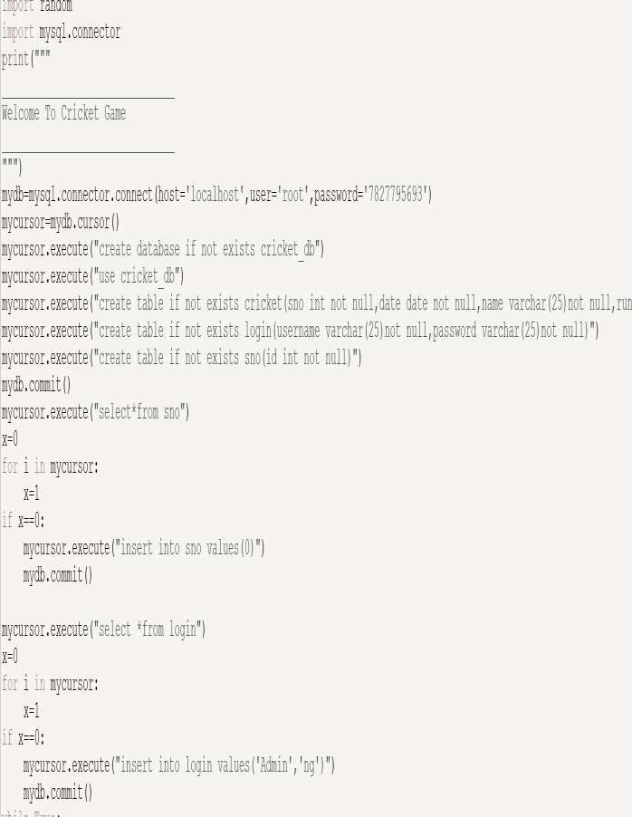
`

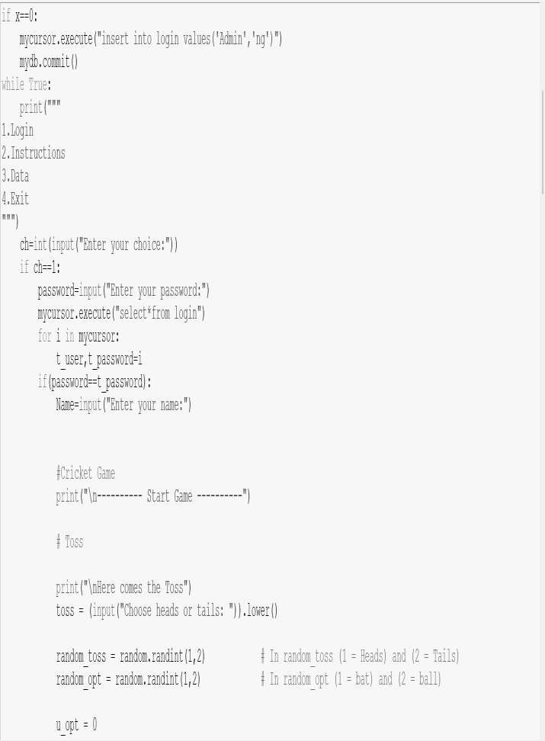

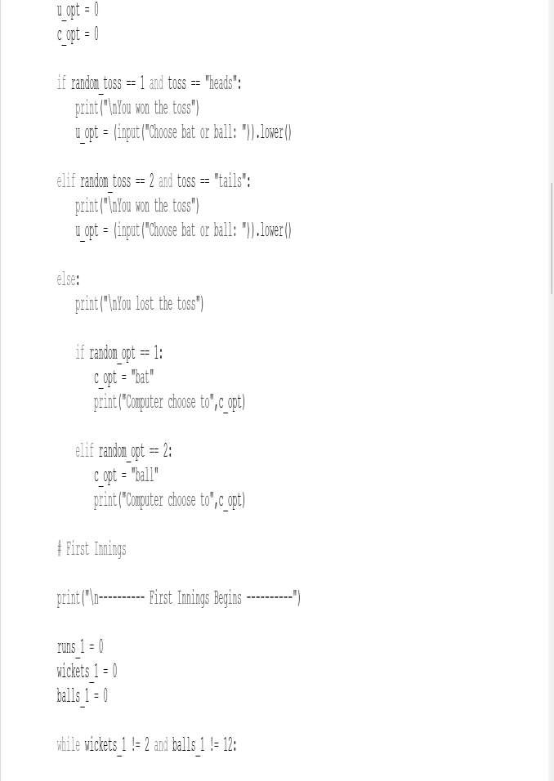

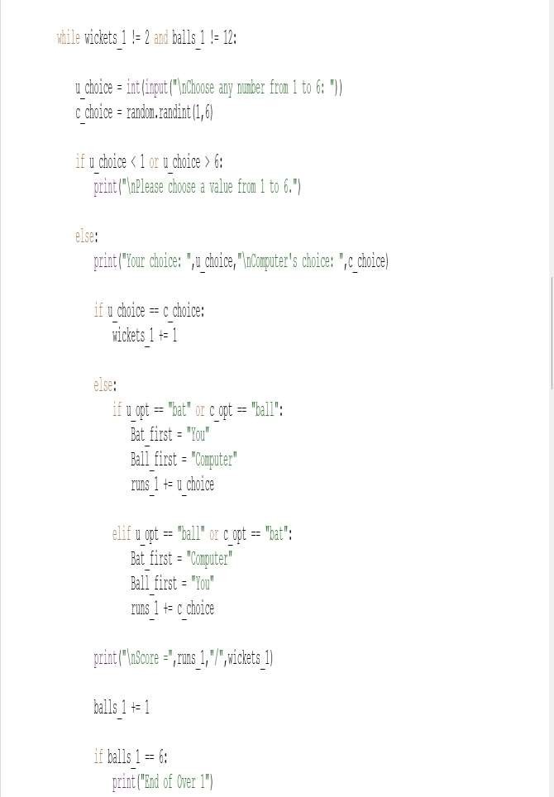

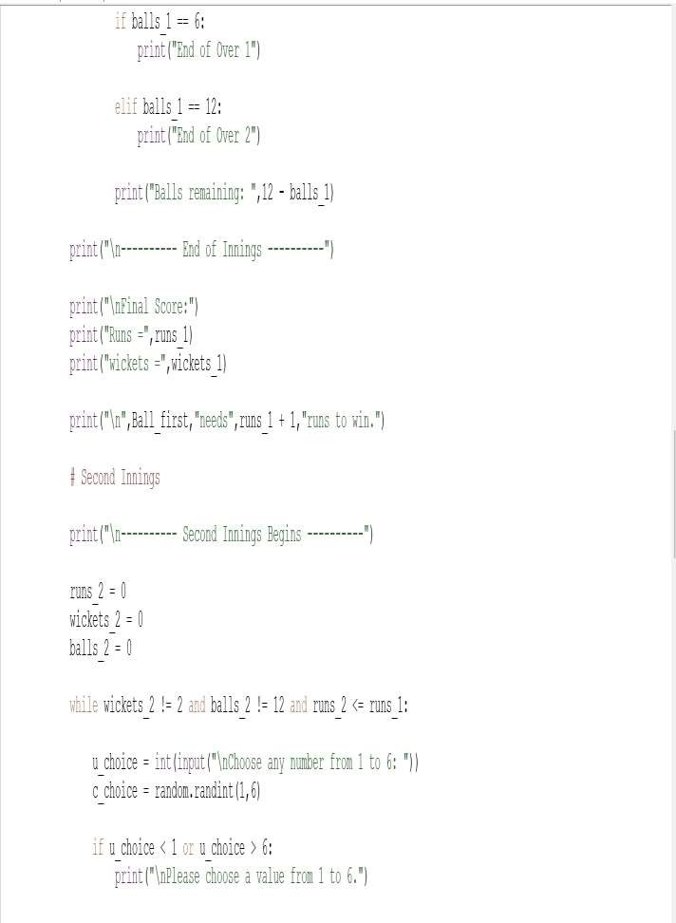

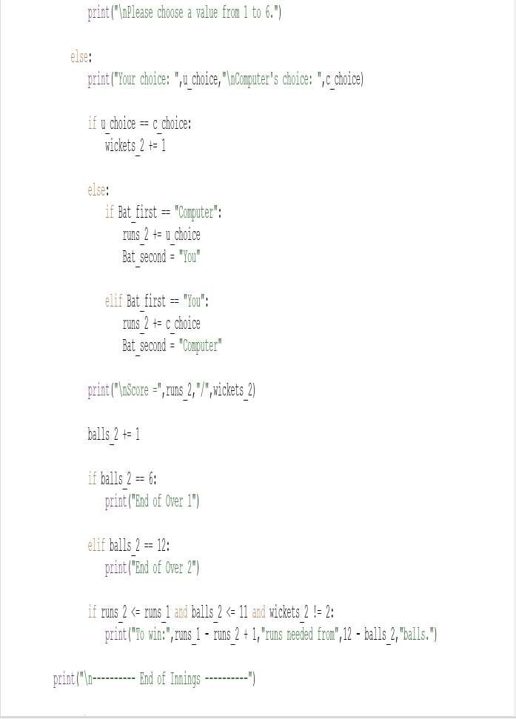

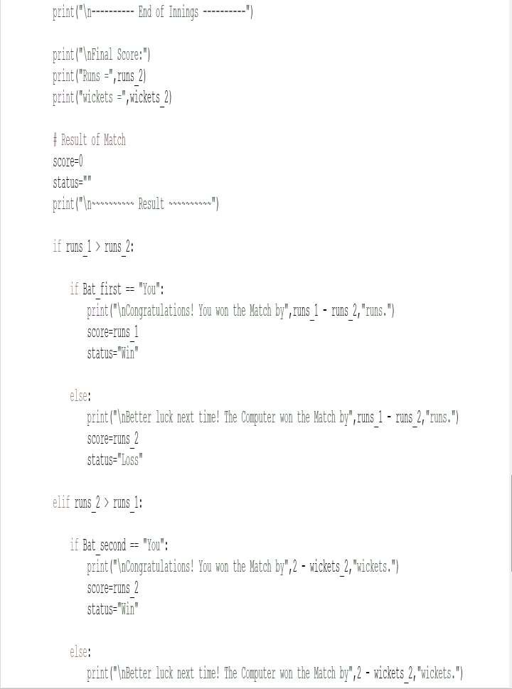

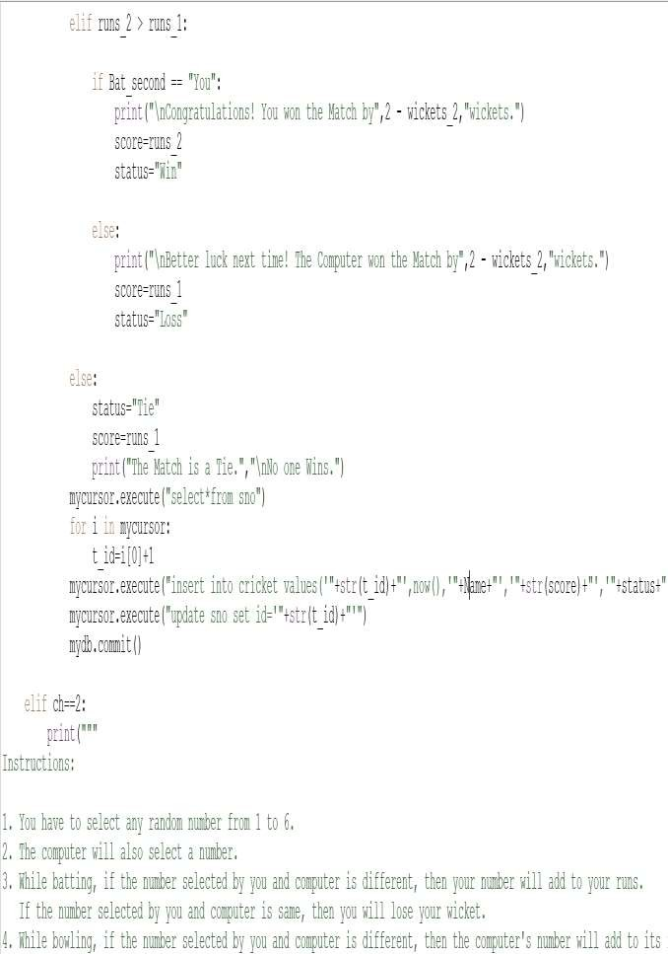

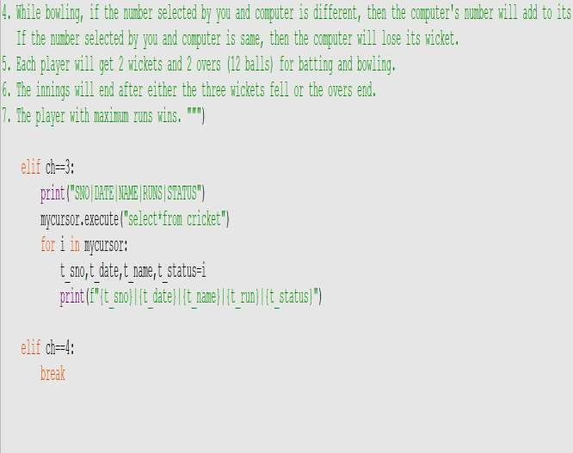

MYSQL CATALOGUE

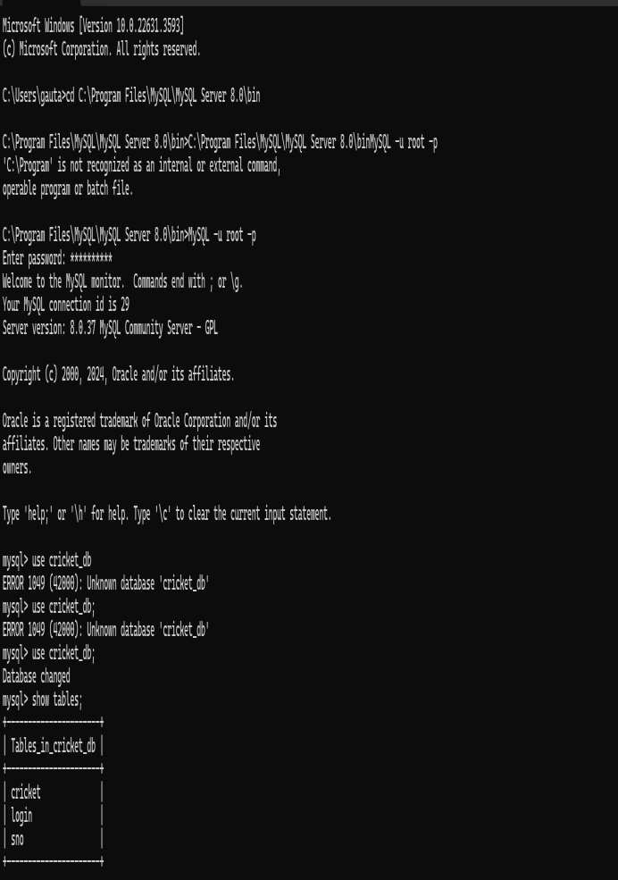

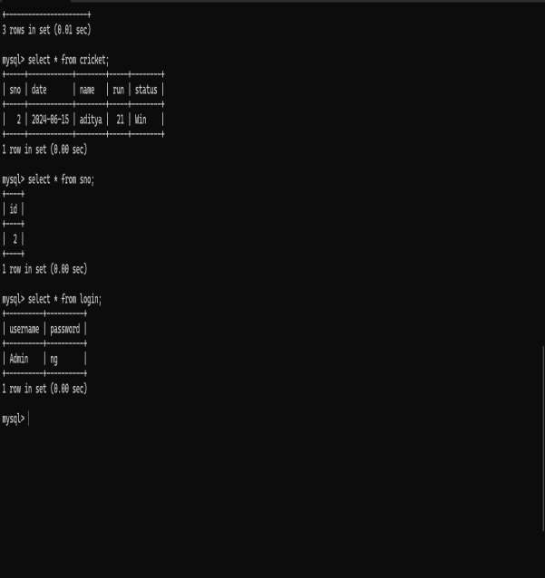

OUTPUT
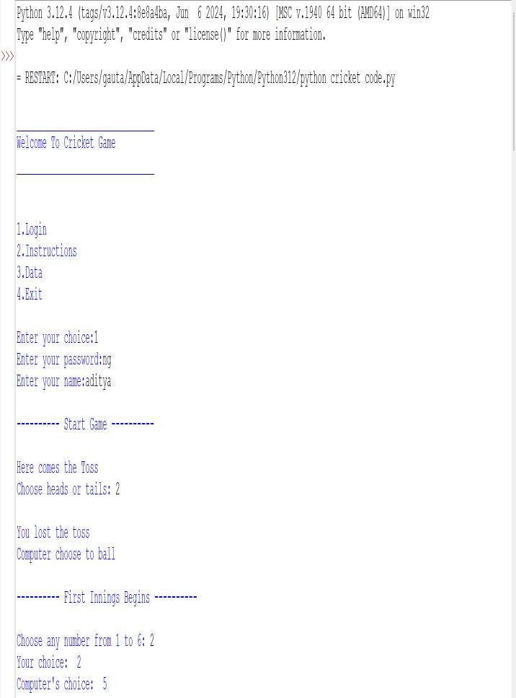

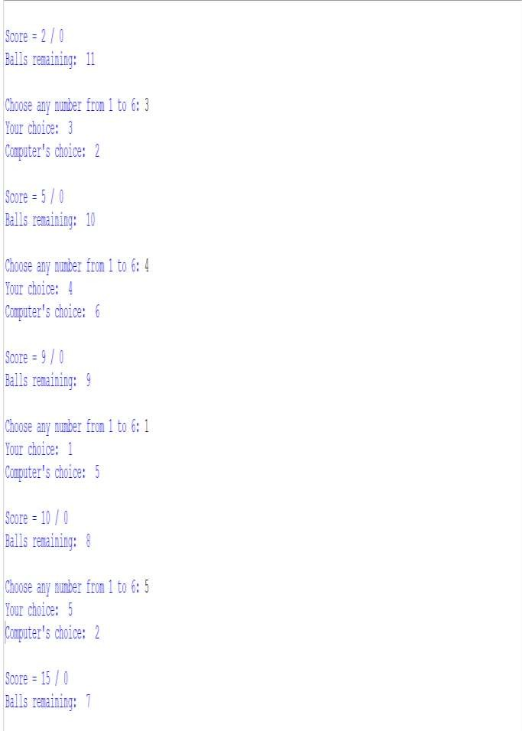

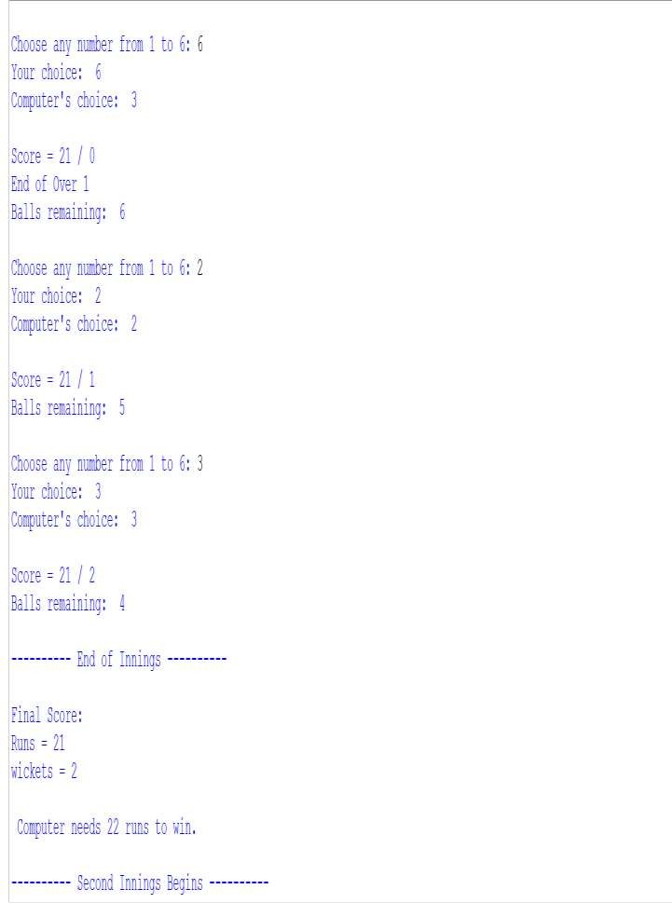

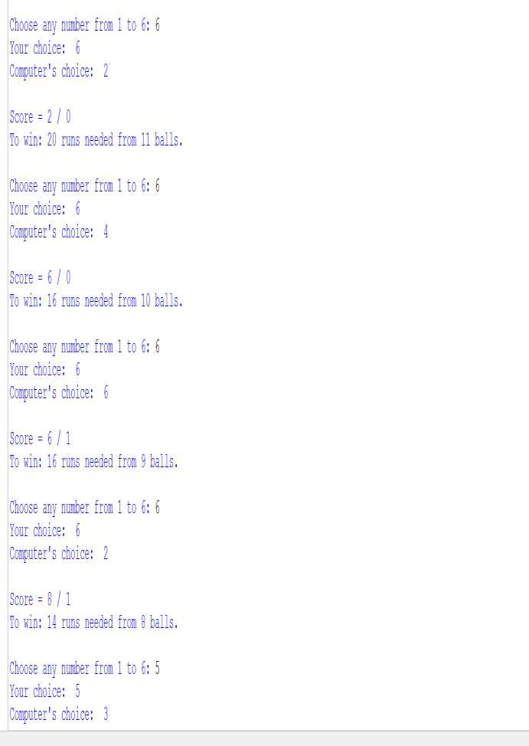

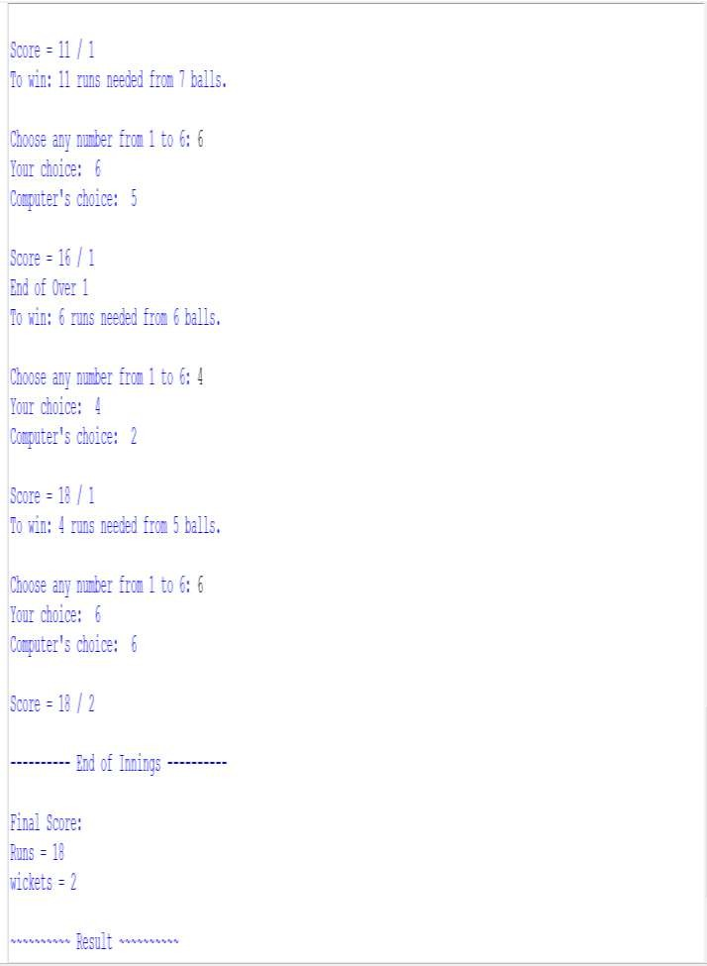

BIBLIGRAPHY

- COMPUTER SCIENCE WITH PYTHON [ CLASS 11 ].
- COMPUTER SCIENCE WITH PYTHON CLASS [ 12 ].
- LINKS :
https://google.com https://www.codeacdemy.com you tube – NG ALL ROUNDER

